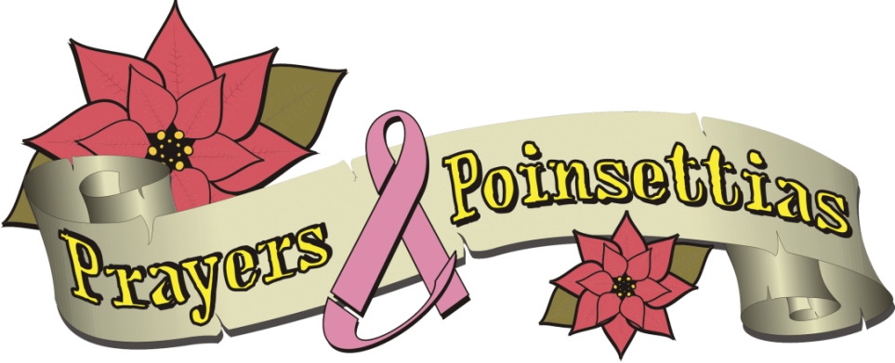

HOLIDAY POINSETTIA SALE

“Our mission is to provide scholarship funds for children whose mothers are suffering with breast cancer.”

- Poinsettias are priced at $22.00 per plant.

- See the attached form for color availability and delivery/pick up information. Please email us at prayersandpoinsettias@gmail.com or visit our website Prayersandpoinsettias.org for further information.

- Deadline for orders is Wednesday, November 16th.

- Orders of less than thirty must be picked up at one of our pick up locations, unless prior arrangements have been made. Special orders of thirty or more will be delivered to a location of the customer’s request within reason. Upon ordering we will contact you with more detailed delivery/pickup information.

Prayers and Poinsettias is a 501(c)(3) approved charity, therefore any purchase is tax exempt and can be used as a tax write off. Donations are also accepted.

Name __________________________________________________________

Email address ____________________________________Phone ______________________________

Pick up location:
- Doylestown Dental Solutions, Mathew Cherian D.M.D. and Larry Stone D.M.D. , 311 Hyde Park, Doylestown (Poinsettias will be available for pickup November 29th. We will text you when they are available. If you are unable to pick up your poinsettias on that date, please contact Mary Beatty at prayersandpoinsettias@gmail.com)

Red # _____ White #_____ Pink # _____ Jingle Bell #_____ Ice Punch #_____ TOTAL # ______

$22.00 each TOTAL $_______

Plants are $22.00 a piece; please make checks payable to Prayers and Poinsettias or visit our website at Prayersandpoinsettias.org to order online. If you are mailing your order please send your check with a printed out copy of your order to: Prayers and Poinsettias, 220 Stone Rd., Barto, Pa 19504

