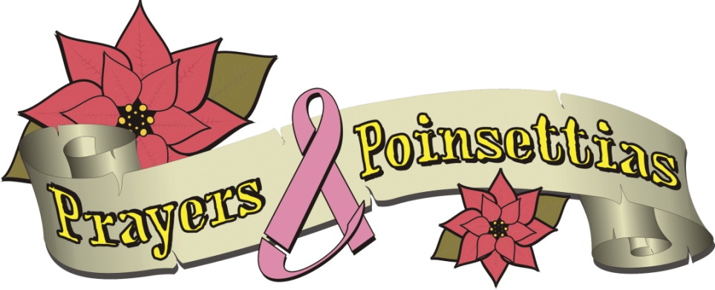

HOLIDAY POINSETTIA SALE

“Our mission is to provide scholarship funds for children whose mothers are suffering with breast cancer.”

Poinsettias are $22.00 per plant.
See the attached form for color availability and delivery/pick up information. Please email us at prayersandpoinsettias@gmail.com or visit our website Prayersandpoinsettias.org for further information.

Deadline for orders is Thursday, November 18th.

Prayers and Poinsettias is a 501(c)(3) approved charity.

Prayers and Poinsettias pick up location at the office of Doylestown Dental Solutions is December 2nd.

Name __________________________________________________________

Email address ____________________________________Phone ______________________________

Pick up location:
Doylestown Dental Solutions, Mathew Cherian D.M.D. and Larry Stone D.M.D. , 311 Hyde Park, Doylestown

Red # _____ White #_____ Pink # _____ Jingle Bell #_____ Ice Punch #_____ TOTAL # ______

$22.00 each TOTAL $_______

Plants are $22.00 a piece; please make checks payable to Prayers and Poinsettias or visit our website at Prayersandpoinsettias.org to order online. If you are mailing your order please send your check with a printed out copy of your order to: Prayers and Poinsettias, 220 Stone Rd., Barto, Pa 19504

