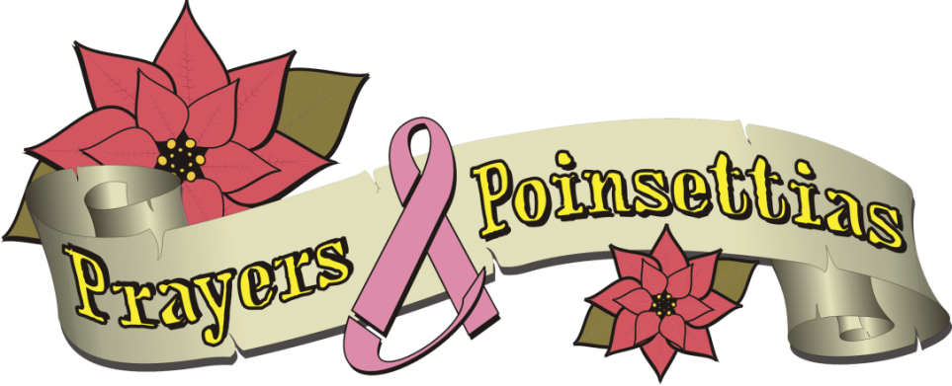

HOLIDAY POINSETTIA SALE

“Our mission is to provide scholarship funds for children whose mothers are suffering with breast cancer.”

Poinsettias are $22.00 per plant.
See the attached form for color availability and delivery/pick up information. Please email us at prayersandpoinsettias@gmail.com or visit our website Prayersandpoinsettias.org for further information.

Deadline for orders is Thursday, November 18th
Orders of less than thirty must be picked up at one of our pick-up locations unless prior arrangements have been made. Special orders of thirty or more will be delivered to a location of the customer’s request within reason. Upon ordering we will contact you with more detailed deliver/pickup information.

Prayers and Poinsettias is a 501(c)(3) approved charity.
Therefore, any purchase is tax exempt and can be used as a tax write off. Donations are also accepted.

Name __________________________________________________________

Email address ____________________________________Phone ______________________________

Pick up locations:
- Boyertown Location, 220Stone Rd. Barto, Pa – Nov. 29th______
- Harleysville Location, 393 Sturgis Rd. Harleysville, Pa - Nov. 30th________

Red # _____ White #_____ Pink # _____ Jingle Bell #_____ Ice Punch #_____ TOTAL # ______

$22.00 each TOTAL $_______

Plants are $22.00 a piece; please make checks payable to Prayers and Poinsettias or visit our website at Prayersandpoinsettias.org to order online. If you are mailing your order please send your check with a printed out copy of your order to: Prayers and Poinsettias, 220 Stone Rd., Barto, Pa 19504

